DESIGN OF GROUND ANCHORS

### A SUMMER INTERNSHIP GROUP PROJECT REPORT

*Submitted by*

Divya Prabha Velayutham (103117034)

Gollapalli Roopa (103117040)

Sarishma Bhandari (103117086)

*in partial fulfilment of the requirements for the award of the degree of*

BACHELOR OF TECHNOLOGY

AT

CIVIL ENGINEERING

*Guided by*

Dr. S. Jayalekshmi



NATIONAL INSTITUTE OF TECHNOLOGY TIRUCHIRAPPALLI – 620015

JANUARY, 2021

# FOREWORD

The corona virus pandemic has affected humans all over the world in numerous ways for almost a year now. Helpless, we students had to leave the university immediately-for it worried both the administration as well as our families of the uncertainties the virus held.

Nonetheless, the diligent efforts of the professors made sure that we were learning whilst fighting the deadly corona virus. That’s why we have been successful in completing two online semesters!!

Due to the Covid-19 situation, our work has been purely theoretical. We weren’t able to do any practical or physically go to the site because of the lockdown. However, we have made use of all the resources available to produce the final outcome of this project.

# ACKNOWLEDGEMENT

This report documents the work done for the internship during the recent summer under the guidance of **Dr. S. Jayalekshmi.** The report gives the detailed information about Ground Anchors, their design procedure and their application in India.

We would like to take this opportunity to thank and express my deepest gratitude to **Dr. S. Jayalekshmi** for the kind encouragement and permission to work in this area. The success and final outcome of this assignment required a lot of guidance and assistance from ma’am and we are extremely fortunate to have got this all along the completion of our assigned work.

We express our grateful thanks to **Dr.G.Swaminathan,** Professor(HAG) and Head of the Civil Engineering Department for the constant encouragement given.

**BONAFIDE CERTIFICATE**

This is to certify that the group project titled, **Design of Ground Anchors** is a bonafide record of the work done by,

**Sarishma Bhandari (103117086)**

**Gollapalli Roopa (103117040)**

**Divya Prabha Velayutham (103117034)**

in partial fulfilment of the requirements for the award of the degree of Bachelor of Technology in Civil Engineering at **NATIONAL INSTITUTE OF TECHNOLOGY, TIRUCHIRAPPALLI,** during the year **2020-2021.**



**03- 01-2021**

Dr. S. Jayalekshmi

Professor in Civil Engineering

Department of Civil Engineering,

NITT

620015

# TABLE OF CONTENTS

## List of Figures

## List of Tables

## Introduction to Ground Anchors

Ground Anchors

Tendons

Types of Ground Anchors

## Objective

## Design of Ground Anchors

Location of Critical Potential Failure Surface

Calculation of Ground Anchor Loads

Design of Unbonded Length

Design of Anchor Bond Length

Space Requirement of Ground Anchors

Selection of Prestressing Steel element

## Design Example

## Protection of Ground Anchors

## Ground Anchors in India

## Conclusion

## References

# 

# LIST OF FIGURES

# Figure Page

# Components of Ground Anchors 8

# Types of Ground Anchors based on Grouting Technique 10

# Steps for Ground Anchor Design 11

# Location of Critical Failure Surface 12

# Apparent Earth Pressure Diagram for sand with one level and multiple level of ground anchors 13

# Apparent Earth Pressure Diagram for stiff to hardclays with one level and multiple level of ground anchors 13

# Tributary Area Method for single ground anchors 14

# Hinge Method for single ground anchors 14

# Vertical and Horizontal spacing requirements for ground anchors 17

# Apparent Earth Pressure for medium dense silty sand 19

1. Design of Ground Anchors for Medium Silty Sand 23

# Corrosion protection of Strand Tendon 24

# Corrosion protection of Bar Tendon 25

# Projects undertaken by FPPC Ltd in India 26

# Stabilization of slope for Parbati Hydroelectric Project 27

# 

# LIST OF TABLES

# Table Page

# Presumptive ultimate values of load transfer for preliminary design of soil 16

# Properties of Prestressing Steel Bars 18

## Introduction to Ground Anchors

**Ground Anchors**

Ground Anchor, also known as grouted ground anchor or tiebacks, is a structural system consisting of prestressed tendons with cement grout that are installed in soil/rock. They are used for transmitting tensile load into the ground.

There are three components of Ground Anchors; **Anchorage**, **Unbonded length** and **Bond length**. The components along with their brief explanation are given below.

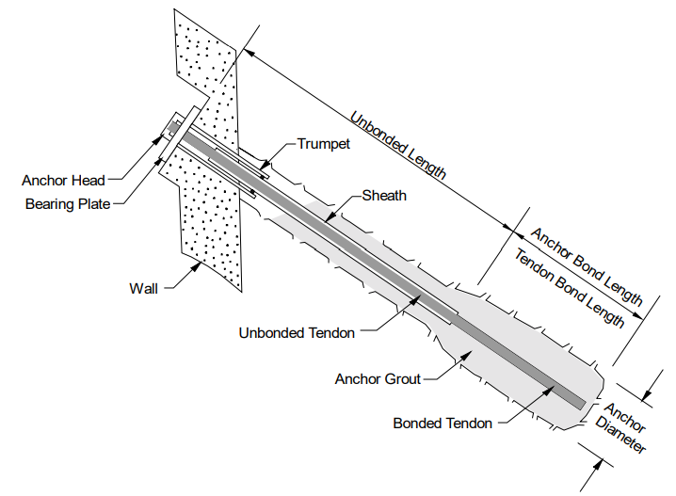

Figure 1: Components of Ground Anchors,

Source: FHWA-IF-99-015

**Anchorage**: It is the combined system of anchor head, bearing plate, and trumpet that is capable of transmitting the pre-stressing force from the pre-stressing steel (bar or strand) to the ground surface or the supported structure.

**Unbonded length**: It consists of a bond breaker (plastic sleeve) which can elongate elastically during testing and stressing. It transfers the resisting force from the bond length to the structure.

**Bond length**: This length is bonded with grout and is capable of transmitting the applied tensile load into the ground. We must always locate the bond length behind the critical failure surface.

**Tendon**

A portion of the complete ground anchor assembly excluding grout and anchorage is referred as tendon. Grout is a Portland cement based mixture that provides load transfer from the tendon to the ground and provides corrosion protection for the tendon.

A tendon includes the prestressing steel element (strands or bars), corrosion protection, sheaths, centralizers, and spacers.

The sheath is a smooth or corrugated pipe or tube that protects the prestressing steel in the unbonded length from corrosion. Centralizers position the tendon in the drill hole such that the specified minimum grout cover is achieved around the tendon. For multiple element tendons, spacers are used to separate the strands or bars of the tendons so that each element is adequately bonded to the anchor grout.

**Types of Ground Anchors**

There are various types of Ground Anchors based on anchorage zone, nature of the structure, installation, application and grouting techniques. All these are briefly explained below.

**Based on Anchorage Zone:**

Rock Anchors- Bonded Length is anchored in the hard rock.

Soil Anchors- Length is anchored in the Soil.

**Based on Design Life:**

Permanent Anchors-They have to guarantee their function during the lifetime of the structures to be anchored. They function for more than 24 months.

Temporary Anchors- These are the prestressed anchors which have to fulfill their function only for a limited time. They are quick to install and are cost effective. They function for less than 24 months.

**Based on the Installation:**

Vertical Anchors- These anchors are provided vertically into the ground.

Inclined Anchors- These anchors are provided at an angle into the ground.

**Based on Application:**

Test Anchors- They are specially designed anchor subjected to extensive tests in order to obtain, either comprehensive information on anchor capacity and geotechnical conditions, or to prove the quality and adequacy of design, material and construction.

Control Anchors- These anchors are present in or beside the structure used for long-term observation. They are equipped with devices, which monitor the variation of forces and displacement.

**Based on Grouting Techniques:**

These can be best explained with the figure below.

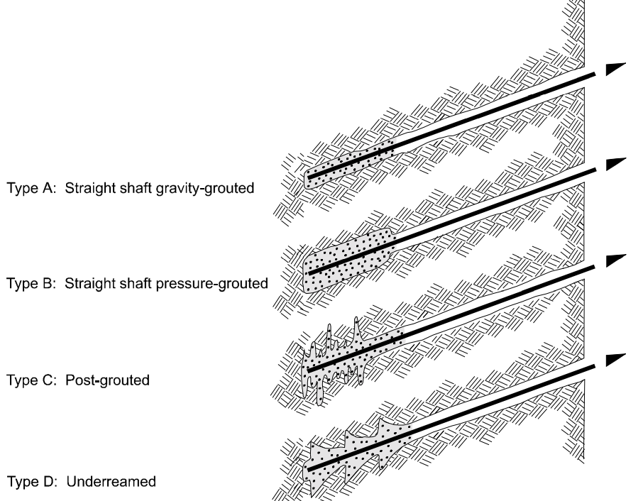

Figure 2: Types of Ground Anchors based on Grouting Technique

Source: FHWA-IF-99-015

Straight shaft gravity-grouted or Tremie anchors:

They are installed in rock or very stiff to hard cohesive soil deposits. Rotary drilling or hollow-stem auger methods can be used with bore hole being cased or uncased depending on the stability.

Straight shaft pressure-grouted anchors:

They are used in coarse granular soils, weak fissured rock or in fine grained cohesionless soils. Rotary or hollow-stem augur may be used with drill casing. Here, the grout is injected into bond zone under pressure.

Post-grouted anchors:

Here, multiple delayed grout injections are used to enlarge the grout body of Straight shaft gravity-grouted anchors.

Underreamed anchors:

They are used in firm to hard cohesive deposits. However, it’s not commonly in use now.

## Objective

Our objective of this report is to Design Ground Anchors for different types of soils using relevant codes and available soil parameters.

1. **Design of Ground Anchors**

For design of ground anchors, following steps should be followed;

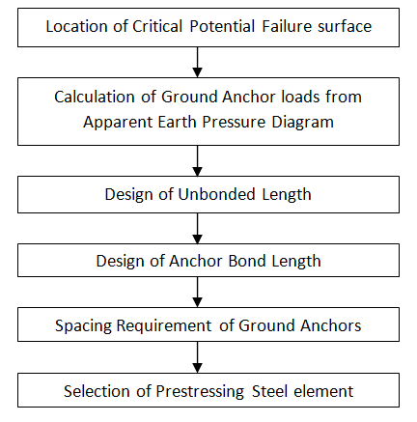

Figure 3: Steps for Ground Anchor Design

**Location of Critical Potential Failure Surface**

The location of the critical potential failure surface must be evaluated since the anchor bond zone must be located sufficiently behind the critical potential failure surface so that load is not transferred from the anchor bond zone into the ‘no-load’ zone.

A ‘no-load’ zone is defined as the zone between the critical potential failure surface and the wall, and is also referred to as the unbonded length. The unbonded length is extended either a minimum distance of H/5, where H is the height of the wall, or 1.5 m behind the critical potential failure surface.

For walls constructed in cohesionless soils, the critical potential failure surface can be assumed to extend up from the corner of the excavation at an angle of 45° - Φ/2 from the vertical.

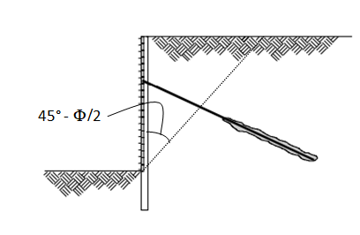

Figure 4: Location of Critical Failure Surface

**Calculation of Ground Anchor Loads from apparent earth pressure diagram**

The Apparent Earth Pressure Envelop for the ground anchors are the modified versions of Terzaghi and Peck diagrams. These envelop depend upon the number of anchors as well on the type of soils.

For sand, the apparent earth pressure diagram for one level of ground anchors is as shown;

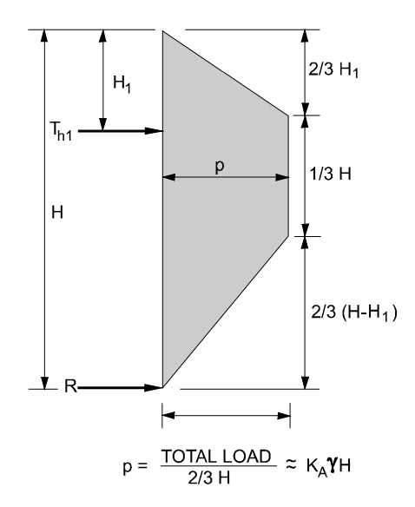 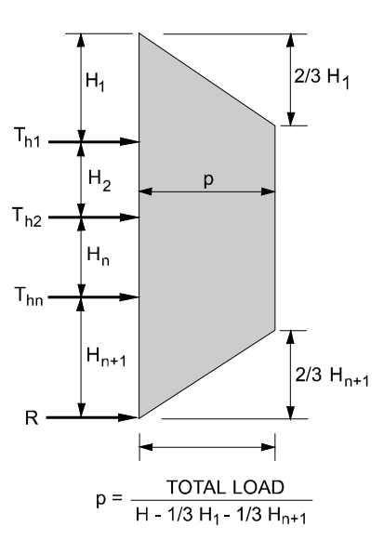

Figure 5: Apparent earth pressure envelop for sand with one level and multiple level of ground anchors

Source: FHWA-IF-99-015

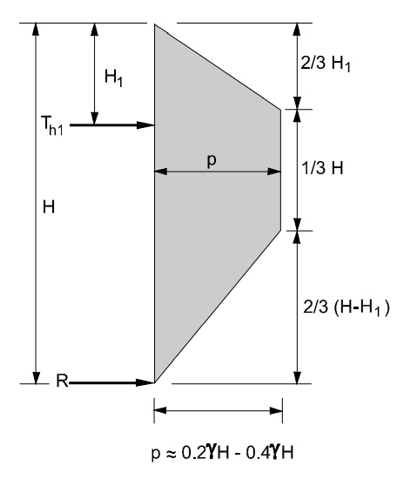 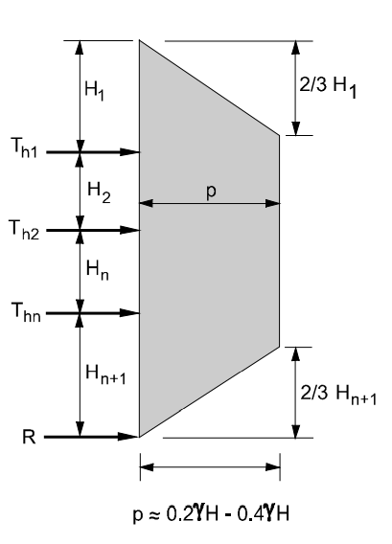

Figure 6: Apparent earth pressure envelop for stiff to hard clays with one level and multiple level of anchors

Source: FHWA-IF-99-015

Where, p is the maximum stress in the earth pressure diagram.

Now, for ground anchor loads we have to first find the horizontal loads. Computing horizontal loads in an indeterminate structure is difficult. So, we use simple methods, Tributary area method and hinge method. These methods help to find the force in the tendon, Th.

For Tributary Method,

We cut the apparent earth pressure diagram with the height H2 into equal halves from which, the lower portion will be equal to Reaction R and upper half will be equal to horizontal load, T1.

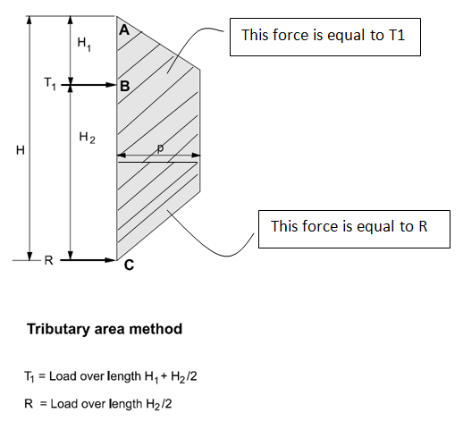

Figure 7: Tributary Area Method for single ground anchors

Source: FHWA-IF-99-015

For Hinge Method,

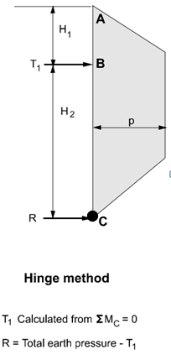

Figure 8: Hinge Method for single ground anchors

Source: FHWA-IF-99-015

Here, we assume that the moment about C is zero. Then we calculate moment about C. We will get the value of T1. For getting the value of R,

R= Total earth pressure- T1

Now after getting the force, T1, total force per anchor is given as,

Where, s is the horizontal anchor spacing and T1 is the calculated force from above methods.

However, we usually use inclined anchors, as shown below,

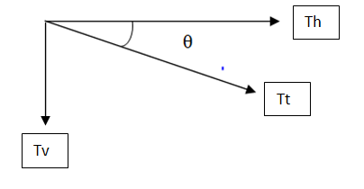

Therefore,

Thus, the required anchored load is Tt as calculated above.

**Design of Unbonded length**

The minimum unbonded length for rock and soil ground anchors is 4.5 m for strand tendons and 3 m for bar tendons.

But longer unbonded lengths may be required while locating the bond length a minimum distance behind the critical potential failure surface, the anchor bond zone in appropriate ground for anchoring, ensuring overall stability of the anchored system and even for accommodating long term movements.

In general, the unbonded length is extended a minimum distance of H/5 or 1.5 m behind the critical potential failure surface to accommodate minor load transfer to the grout column above the top of the anchor bond zone.

**Design of Anchor bond length**

IS 10270-1982 only provides guidelines for anchor bond length for rock anchors. For soil anchors, we can use Geotechnical Engineering Circular No. 4 published by U.S Department of Transportation, Federal Highway Administration (FHWA).

Here, we use the estimated ultimate transfer load to decide our anchor bond length based on the type of soil and relative density for ground anchors with small diameter. We use the factor of safety 3.

For instance, after knowing our design anchor load, Tt, we equate to find the anchor bond length as follows,

We can get the value of Ultimate load transfer from Table 1

Table 1- Presumptive ultimate values of load transfer for preliminary design in soil.

Source: FHWA-IF-99-015

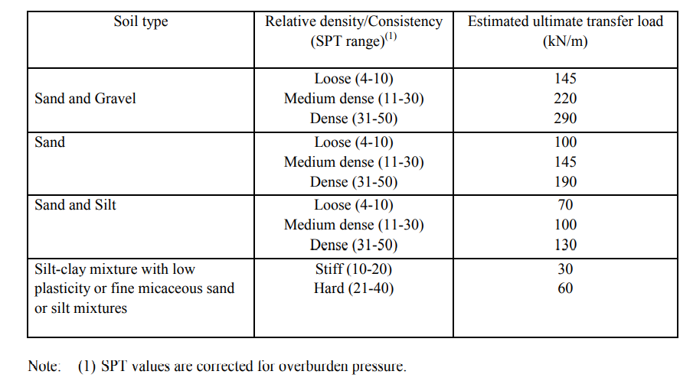

We need to note that, the tabulated values are only for preliminary design. We have to test the anchors after installation to get the exact value of load transfer.

**Spacing requirement of Ground Anchors**

The horizontal and vertical spacing of the ground anchors will vary depending on specific requirements and constraints such as existing underground structures that may affect the positioning and inclination of the anchors, type of vertical wall elements selected for the design, etc.

For ground anchors installed in soil, a minimum overburden of 4.5 m over the center of the anchor bond zone is required.

The maximum horizontal spacing between anchors is based on allowable individual ground anchor loads and flexural capacity of individual soldier beams or sheet pile sections. Typical horizontal spacing for soldier beams is 1.5 m to 3 m for driven soldier beams and up to 3 m for drilled-in soldier beams. This minimum horizontal spacing between anchors ensures that group effects between adjacent ground anchors are minimized and that anchor intersection due to drilling deviations is avoided.

Group effects reduce the load carrying capacity of individual ground anchors.

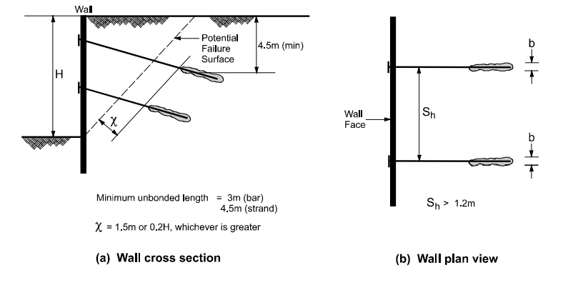

Figure 9- Vertical and horizontal spacing requirements for ground anchors

Source: FHWA-IF-99-015

**Selection of Prestressing steel element**

According to IS 10270-1982 for prestressed rock anchors, the number of wires and strands are provided such that the initial prestressing force is at a level of 70% of guaranteed ultimate tensile strength of the steel.

For soils however, design load and the lock-off load, separate factors of safety are applied with respect to the potential failure mechanism of tendon breakage. The design load shall not exceed 60 percent of the specified minimum tensile strength (SMTS) of the prestressing steel. The lock-off load shall not exceed 70 percent of the SMTS and the maximum test load shall not exceed 80 percent of the SMTS.

Dimensions and strengths of bars and strands commonly used in the U.S. for highway applications are provided in Table 2 which is taken from page number 77 of Geotechnical Engineering Circular No. 4 published by U.S Department of Transportation, Federal Highway Administration (FHWA).

Table 2- Properties of prestressing steel bars

Source: FHWA-IF-99-015

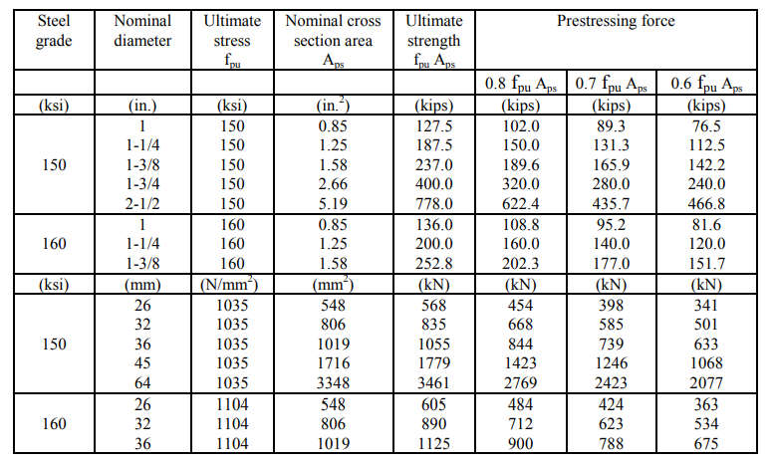

1. **Design Example**

Let us assume the unit weight of soil as 18kN/m3 and effective friction angle of 33°. The depth of excavation is 10m, the first anchor at 2.5m from above and the second anchor at 3.75m from below. Let inclination of both anchors is 15°and soldier beam centre-centre spacing is 2.5m.

STEP 1: Location of Critical Potential Failure Surface

The critical failure surface may be assumed to intersect the corner of the wall and exit at the ground surface and be sloped at 45°+Φ/2 from the horizontal where Φ is equal to the effective stress friction angle of the soil behind the wall.

STEP 2: Calculation of Ground Anchor Loads from Apparent Earth Pressure Diagram

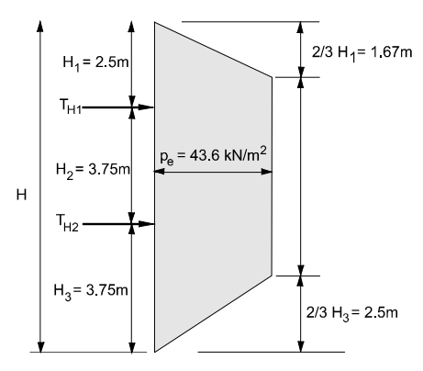

Figure 10- Apparent Erath Pressure for medium dense silty sand

Source: FHWA-IF-99-015

Now, calculating horizontal anchor loads using Tributary Area Method.

For Top Ground Anchor,

The horizontal anchor load for the top most anchor is, 154.445kN/m

Anchor Design Load for Top anchor is,

The Design Anchor Load for the top anchor is, 399.7kN.

For Bottom Ground Anchor,

The horizontal anchor load for the bottom anchor is, 102.6kN/m

Anchor Design Load for Bottom anchor is,

The Design Anchor Load for the bottom anchor is, 265.537kN.

Therefore, the maximum anchor design load is, 399.7 kN.

The reaction force, R, to be resisted by the subgrade is assumed to act at the base of the excavation and is calculated using Tributary Area Method as follow,

STEP 3: Design of Unbonded Length

Since, the minimum unbonded length for rock and soil ground anchors is 4.5 m for strand tendons and 3 m for bar tendons, assuming bar tendon our unbounded length will be,

Therefore, the unbounded length will be 5m.

STEP 4: Design of Anchor Bond Length

Here, we use the estimated ultimate transfer load to decide our anchor bond length based on the type of soil and relative density for ground anchors with small diameter. We use the factor of safety 3.

Assuming our anchor bond zone as medium dense silty sand, let us select the load transfer as 100kN/m from Table 1, as shown below,



Now, for the length of 13m the bond strength is,

Since our Bond Strength is greater than maximum design load, the design load can be attained at this site for the assumed anchor spacing and inclination.

STEP 5: Space Requirement of Ground Anchors

Since, we have already assumed the horizontal and vertical spacing at the beginning and the specified requirements satisfy our criteria we can use the same values.

Vertical Spacing= 3.75

Horizontal Spacing 2.5m

STEP 6: Selection of Prestressing Steel element

Although the site soils are classified as non-aggressive, the consequence of failure is considered serious. Therefore, a Class I (double protection) encapsulated tendon should be selected.

A 32-mm diameter, Grade 150 prestressing bar may be selected, based on an allowable tensile capacity of 60 percent of the specified minimum tensile strength (SMTS).

The allowable tensile capacity is 501 kN which exceeds the calculated maximum design load of 399.7 kN. The minimum estimated trumpet opening is 95 mm for a Class I corrosion protection system.

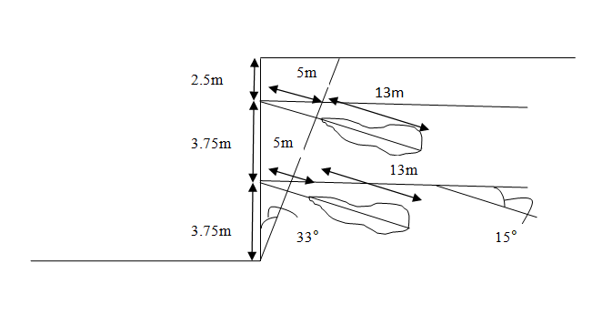

Figure 11- Design of Ground Anchors for Medium Silty Sand

1. **Protection of Ground Anchors**

After designing ground anchors, adequate steps for ensuring durability of ground anchor against corrosion are necessary.

Corrosion protection for ground anchor tendons includes either one or more physical barrier layers. The barrier layers include anchorage covers, corrosion inhibiting compounds, sheaths, encapsulations, epoxy coatings, and grouts. The selection of the physical barrier depends on the ground environment, design life of the structure (i.e., temporary or permanent), the consequences of failure of the anchored system, and the additional cost of providing a higher level of protection.

The design of corrosion protection systems is performed to protect the steel components of the ground anchor. Steel components of the anchor include the anchor head, bearing plate, trumpet, prestressing steel and couplers.

Components of the corrosion protection system include,

1. For the anchorage, a cover or concrete embedment, a trumpet, and corrosion inhibiting compounds or grout.
2. For the unbonded length, grout and a sheath filled with a corrosion inhibiting compound or grout.
3. For bond length, grout and encapsulations with centralizers or epoxy coatings.

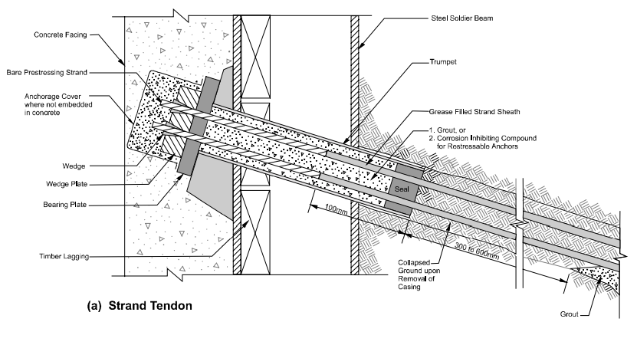

Figure 12- Corrosion protection of Strand Tendon

Source: FHWA-IF-99-015

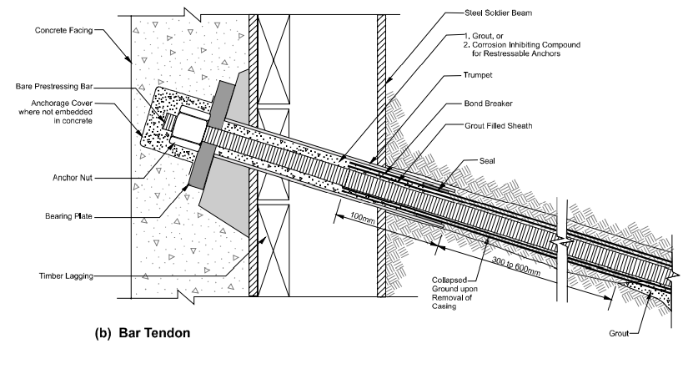

Figure 13- Corrosion protection of Bar Tendon

Source: FHWA-IF-99-015

1. **Ground Anchors in India**

Though there are not enough guidelines provided for Design of Ground Anchors in IS code, its use has been gaining popularity. Some of the companies that provide anchoring projects in India are;

1. Keller
2. BAUER Groups
3. KGN Prestress
4. Sanfield India Ltd.
5. FPCC Ltd.
6. BBR (India) Pvt. Ltd

Some of the projects FPPC Ltd are shown below,

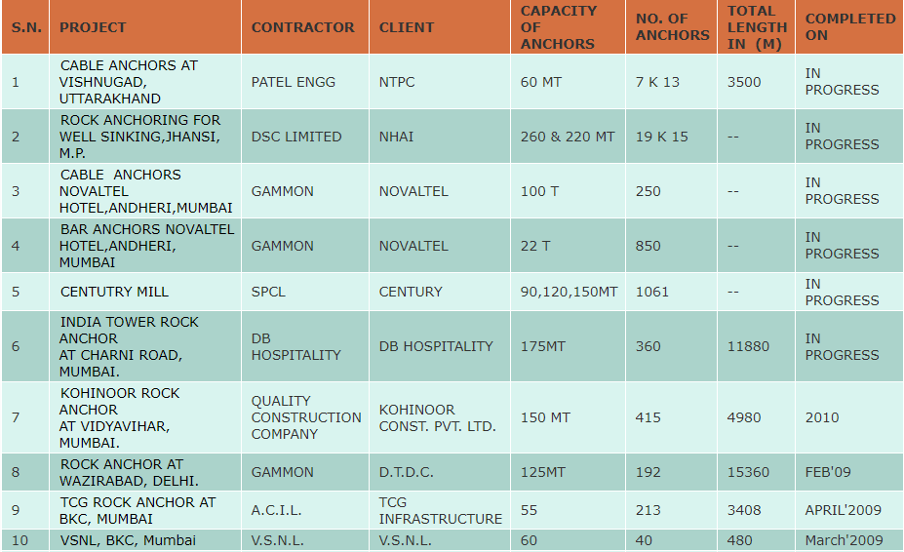

Figure 14- Projects undertaken by FPPC Ltd in India

Source: <https://freyssinet-india.com/services_ground_anchors>

Parbati Hydroelectric Project, Himachal Pradesh located in the hilly terrain of Kullu faced a challenge. During construction of the power house a portion of the slope behind the power house collapsed.

To prevent further landslides and caving, a system of prestressed anchors and rods was devised to stabilize the slopes. Freyssinet 12K13 tendons were used. Shortcreting was done on the slopes after anchoring of the tendons to prevent damage to the slopes due to water. A total area of 90m*175m was stabilized in this manner.

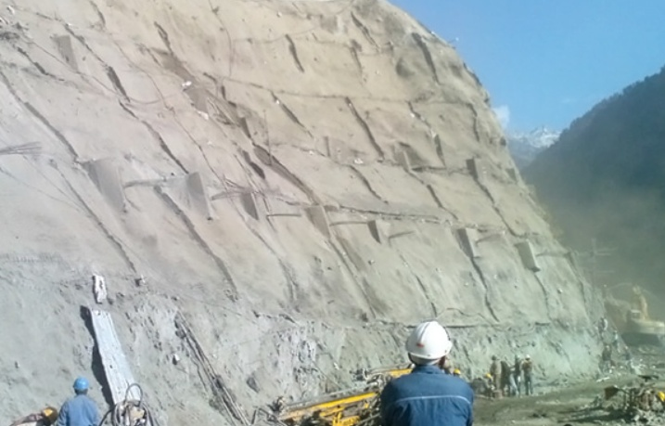

Figure 15- Stabilization of slope for Parbati Hydroelectric Project

Source: <https://freyssinet-india.com/projects-post-tensioning-ground-anchors-parbati-hydroelectric>

1. **Conclusion**

Ground Anchors were only used for temporary systems until there was upgrade in the design and materials used.

Mostly for retention of earth, landslide stabilization we used conventional concrete gravity retaining walls. These needed deep foundation support, more materials, more labours, more construction time, selected backfill, etc. Use of Ground Anchors can eliminate mentioned drawbacks otherwise seen on the conventional concrete gravity retaining walls.

Anchored walls, a common application of Ground Anchors, has the ability to withstand relatively large horizontal pressures without requiring significant increase in wall cross section and eliminate the need of selected backfill. Use of anchored walls in Highway construction will reduce the acquisition of right-of-way.

Even though Ground Anchors have extensive applications, there isn’t adequate IS Codes for Design.

One of the major problems we faced was inadequate sources for design of ground anchors. There was only one IS Code which gave us limited information about design of pre- stressed rock anchors. Thus, we had to rely upon US Department of Transportation FHWA (Federal Highway Administration) Publication for in-depth knowledge about ground anchors design. Through this Report the clear initiation of a manual of Design of Ground Anchors here in India is attempted.

1. **References**
2. Geotechnical Engineering Circular No. 4 published by U.S Department of Transportation, Federal Highway Administration (FHWA)
3. IS Code 10270 (1982): Guidelines for design and construction for Prestressed Rock Anchors.
4. Geotechnical Engineering Classes by Professor Kitch.
5. <https://freyssinet-india.com/services_ground_anchors> for Ground Anchors Projects in India
6. <https://freyssinet-india.com/projects-post-tensioning-ground-anchors-parbati-hydroelectric>